physics formulas MEETLEARN.COM

Cameroon GCE Board retains the full right as the compiler and owner of these formulas. The formulas as published on this site are to facilitate teaching and learning and should not be used for any commercial purpose whatsoever
  - Advanced Level Physics

PHYSICS USEFULA DATA

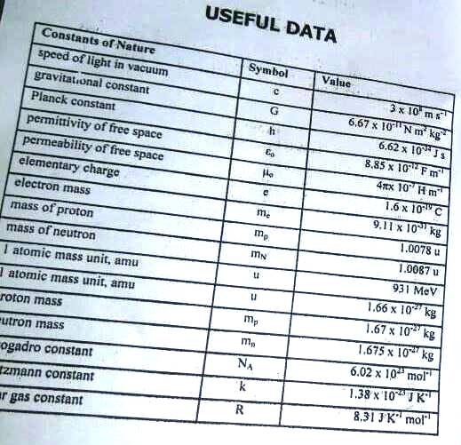

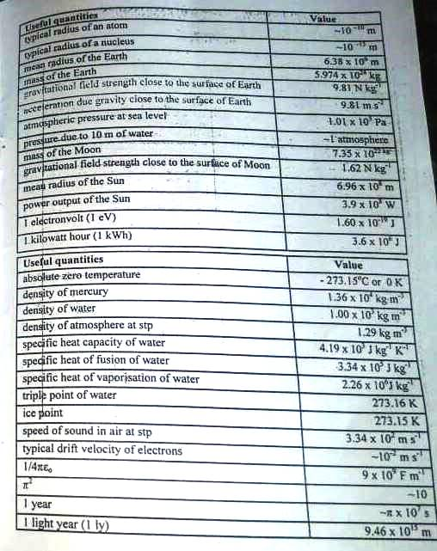

MECHANICS
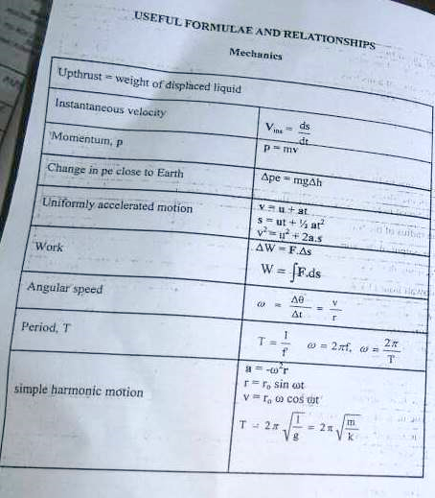

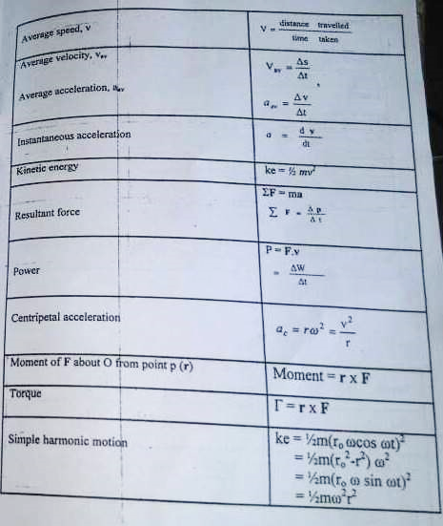
ENERGETICS
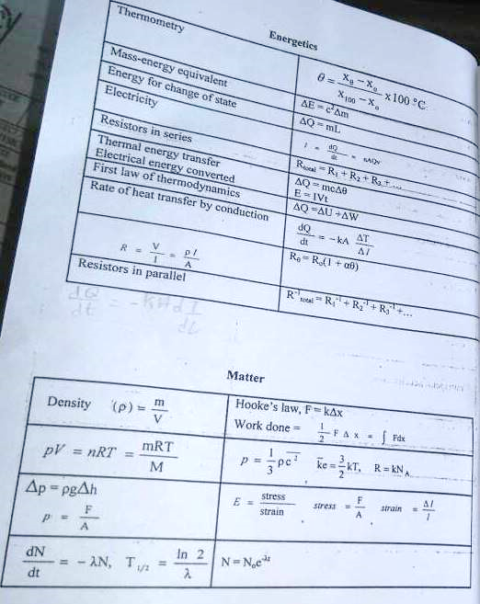
FIELDS
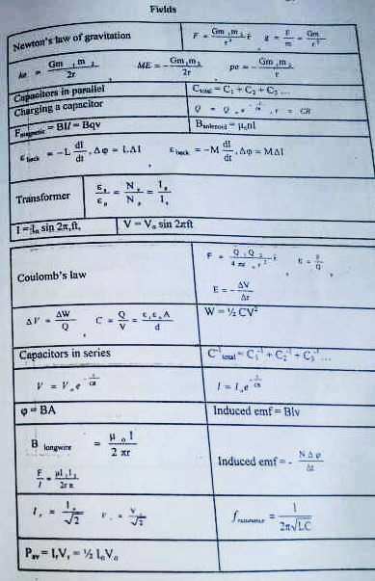

WAVES

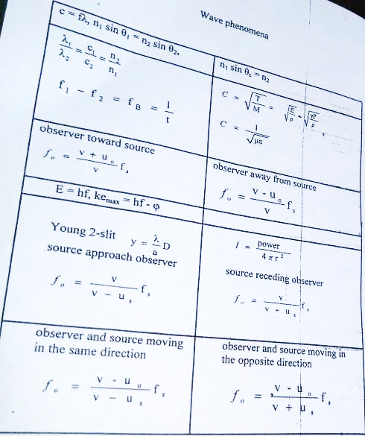

RELATIVITY
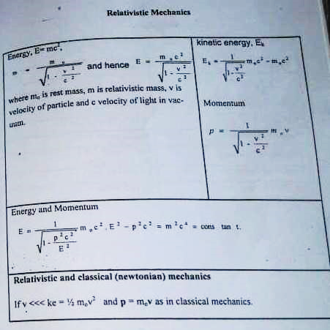

FOR ALL YOUR EDUCATIONAL NEEDS, WRITE TO
MEETLEARN FOUNDATION
DOUALA CAMEROON
Email : study@meetlearn.com
Website : www.meetlearn.com
Facebook : www.facebook.com/MeetLearnCameroon

