PAST GCE QUESTIONS MEETLEARN.COM

Cameroon GCE Board retains the full right as the creator and owner of these past questions. The questions as published on this site are to facilitate teaching and learning and should not be used for any commercial purpose whatsoever

2016 Past GCE Advanced Level Paper 2

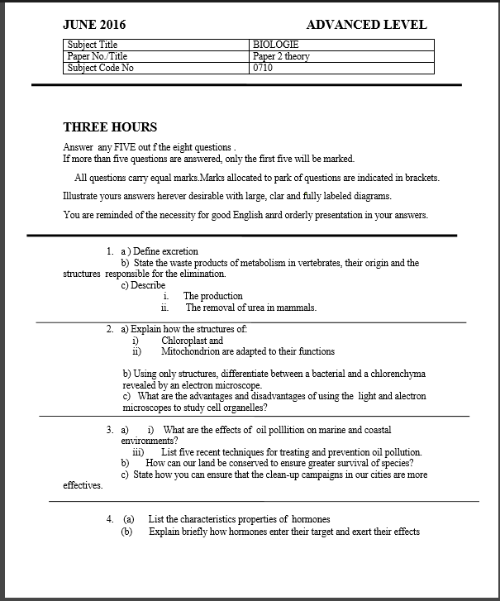

MEETLEARN.COM

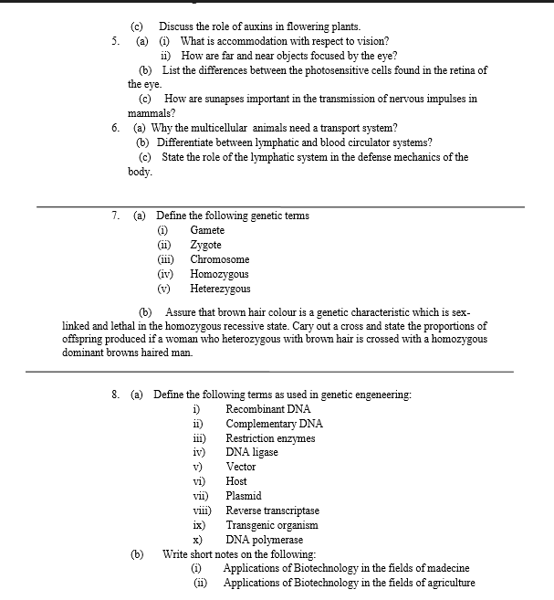

MEETLEARN.COM